Task 3: Data Analysis with Pandas

Objective
Load a CSV dataset, inspect and analyze the data using Pandas, apply filtering and aggregation, and generate simple business insights.

Tools Used
Python 3.14, Pandas, VS Code

Project Summary
The dataset contains product sales information including Product, Category, Price, and Quantity. Revenue was calculated and analysis was performed using filtering, grouping, and aggregation.

Source Code
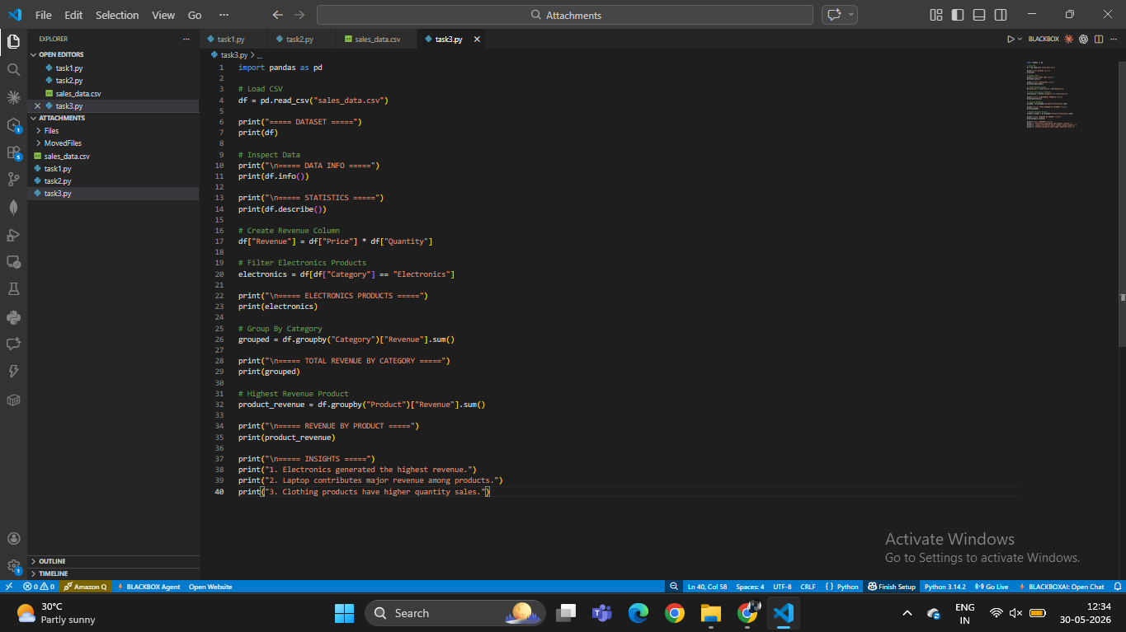

Dataset Output
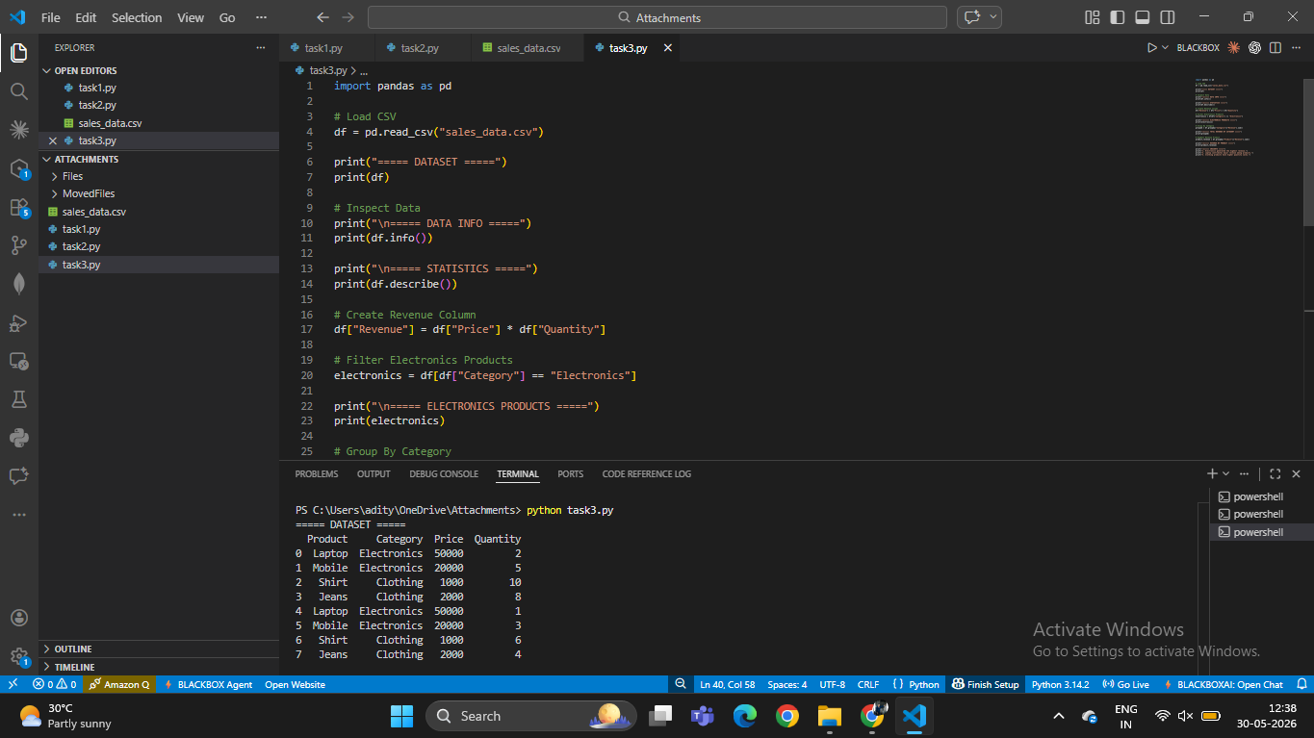

Data Information
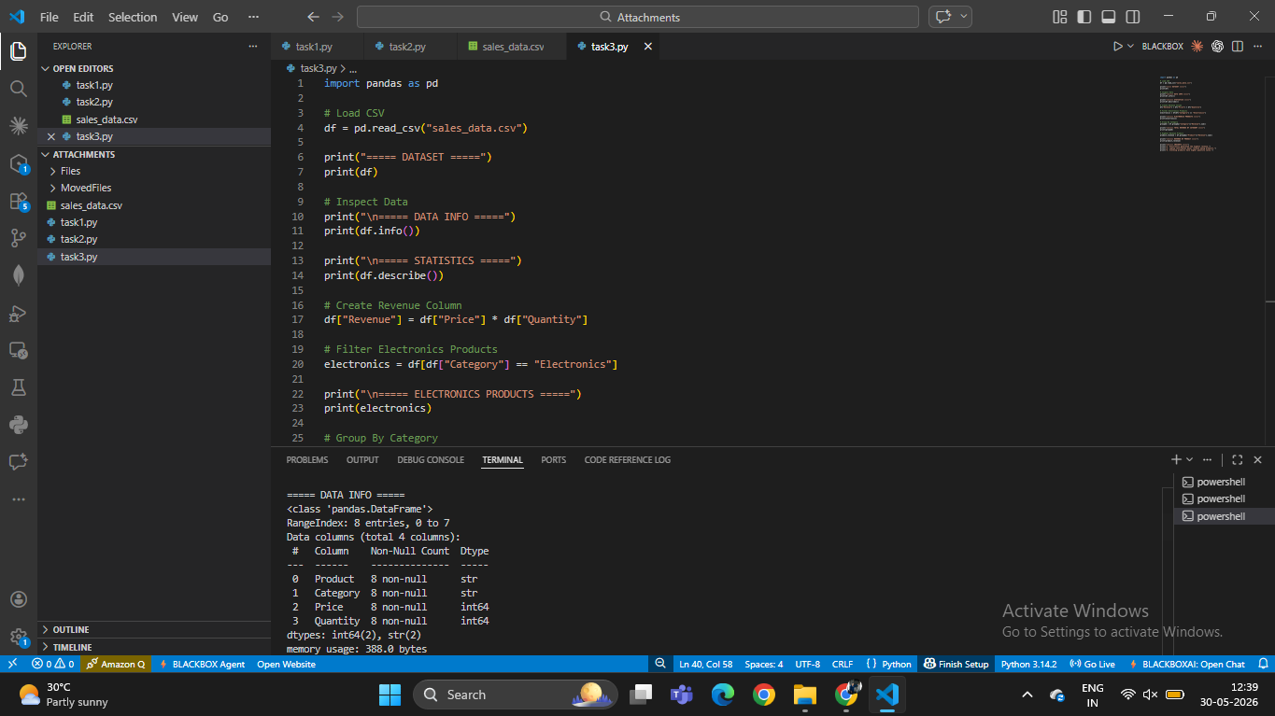

Statistics Output
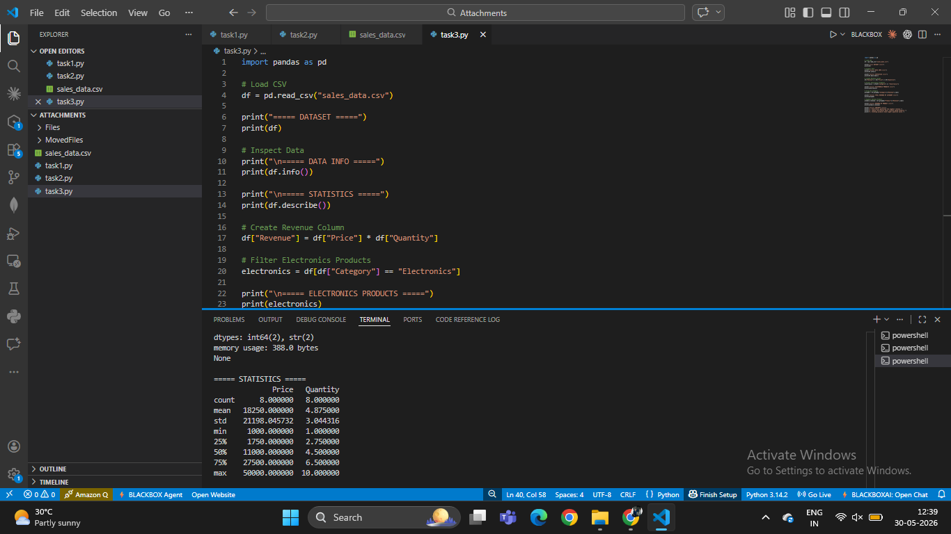

Electronics Products & Category Revenue
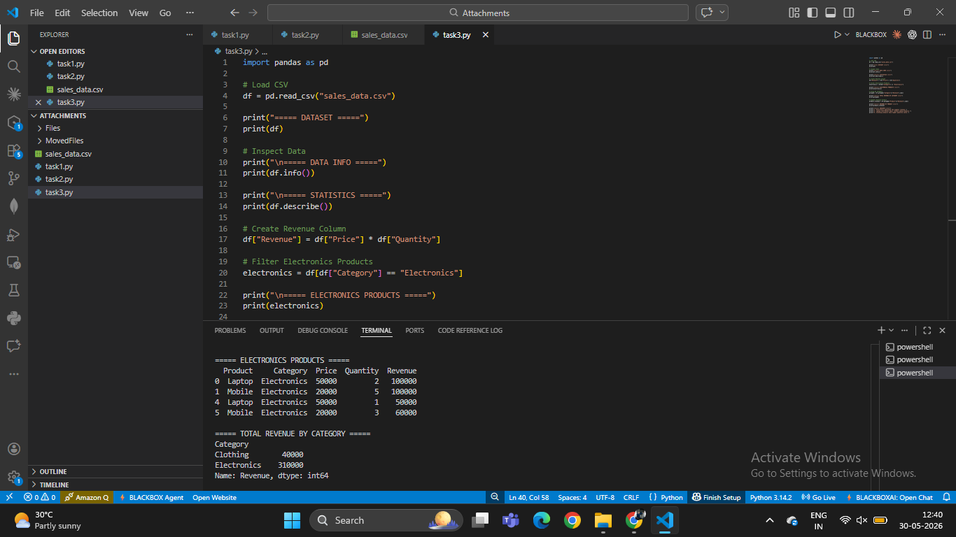

Revenue by Product
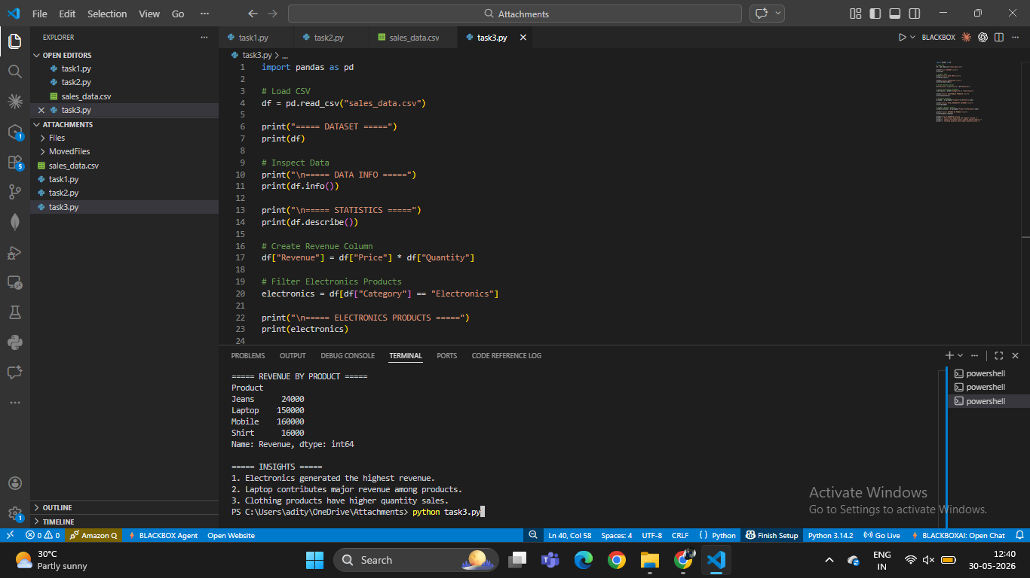

Final Insights
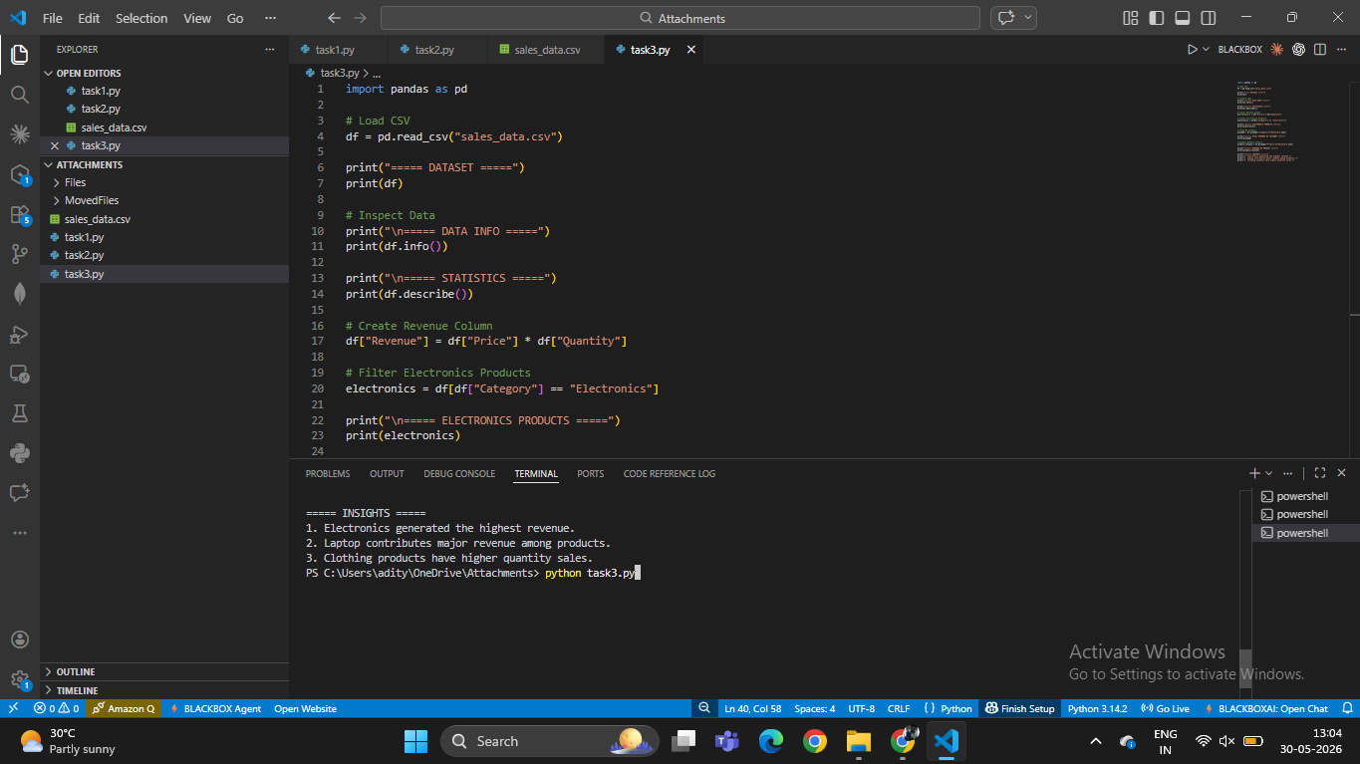

Insights
1. Electronics category generated the highest revenue.
2. Laptop contributed significant revenue among all products.
3. Clothing products recorded higher quantity sales.

Conclusion
The objective of the task was successfully completed using Pandas. Data loading, inspection, filtering, grouping, revenue calculation, and insight generation were performed successfully.

